IMPLEMENTING CRM FOR RESULT TRACKING OF A CANDIDATE WITH INTERNAL MARKS

**1.Introduction**

1.1 Overview

The improved features of CRM software have increased both its complexity and necessity. Nearly half of CRM implementation capmpaigns suffer from improper preparation and misaligned objectives among internals stakeholders. A properly conceived CRM implementation stratergy covers the breakdown of its goals, research stratergy, development and future. This article is for small business owners who want to make sure they are taking the right steps when implementing a new CRM system.

1.2 Purposal

It is saves a lot of time. The purpose of the project is to manage the school students result tracking in the easy way. Students do not need to check the notice board and everyone will stay updated that is the main purpose of this project. Can work easily. Increas candidate quality.

**2. Problem Deflinitions & Design Thinking**

2.1 Empathy Map

An Empathy map is a collaborative visualization used to articulate what we know about a particular type of user. It externalizes knowledge about a users in order to

1) Create a shared understanding of user needs,

2) Aid in decision marketing.

..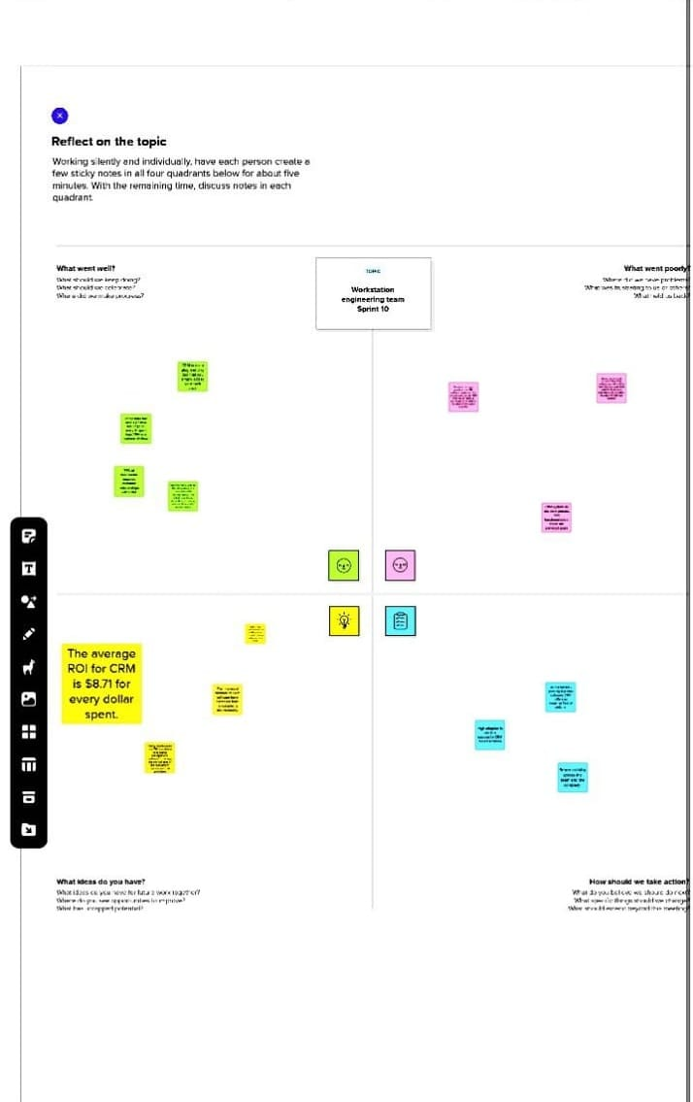

**2.2 Ideation & Brainstroming Map**

Brainstroming is a group proble-solving methood that involves that spontaneous contribution of creative ideas and solution. This technique requries intensive, freewheeling discution in which every member of the group is encouraged to think aloud and suggest as many ideas as possiblee based on their diverse knowledge.

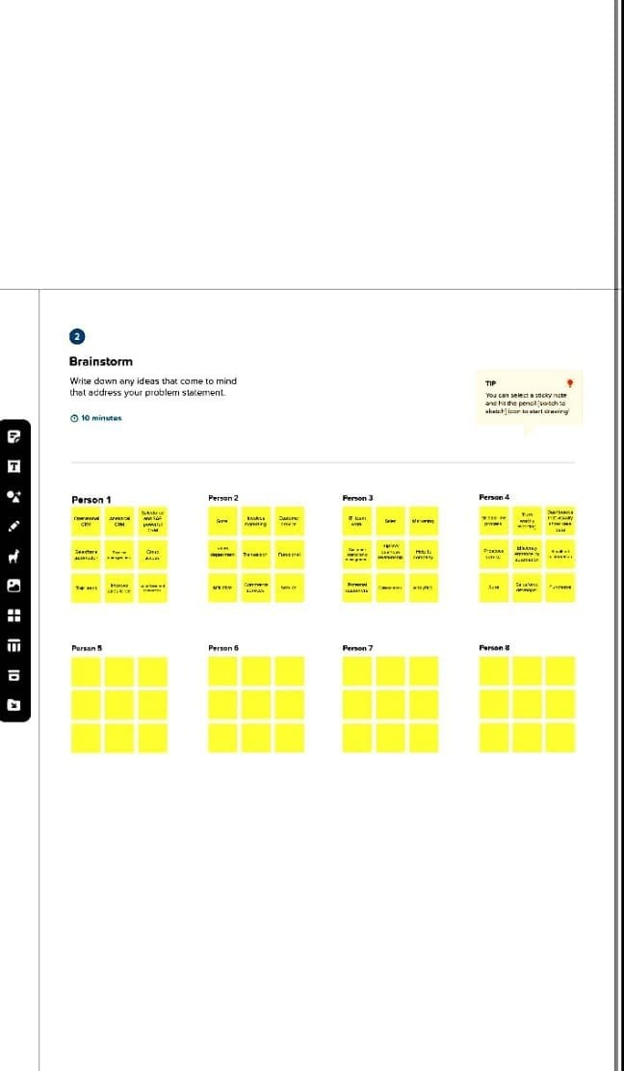

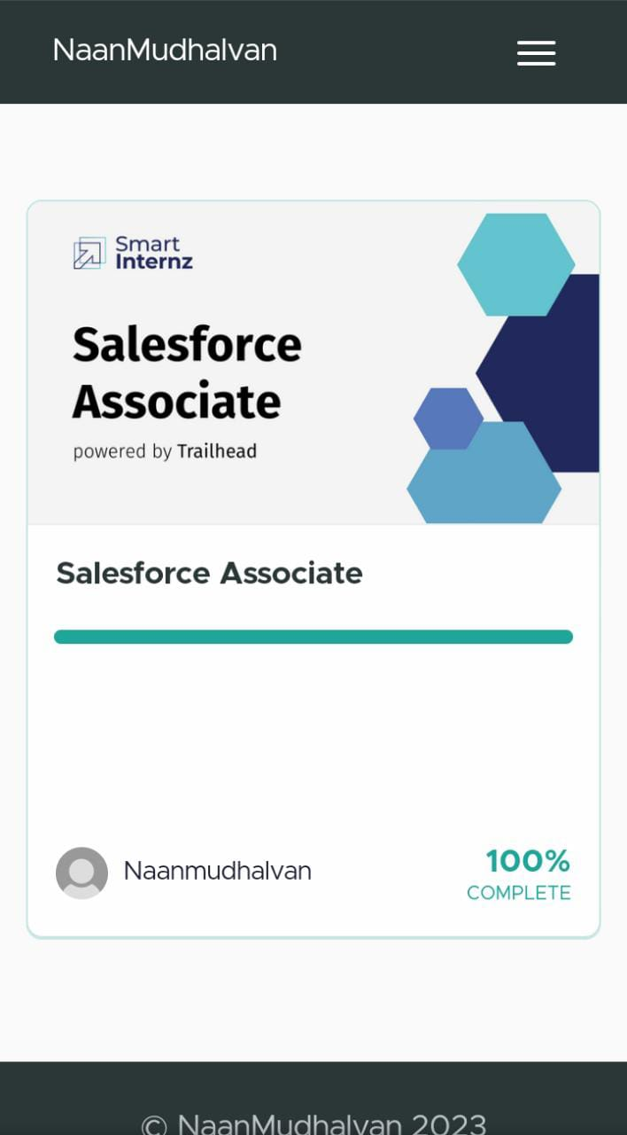

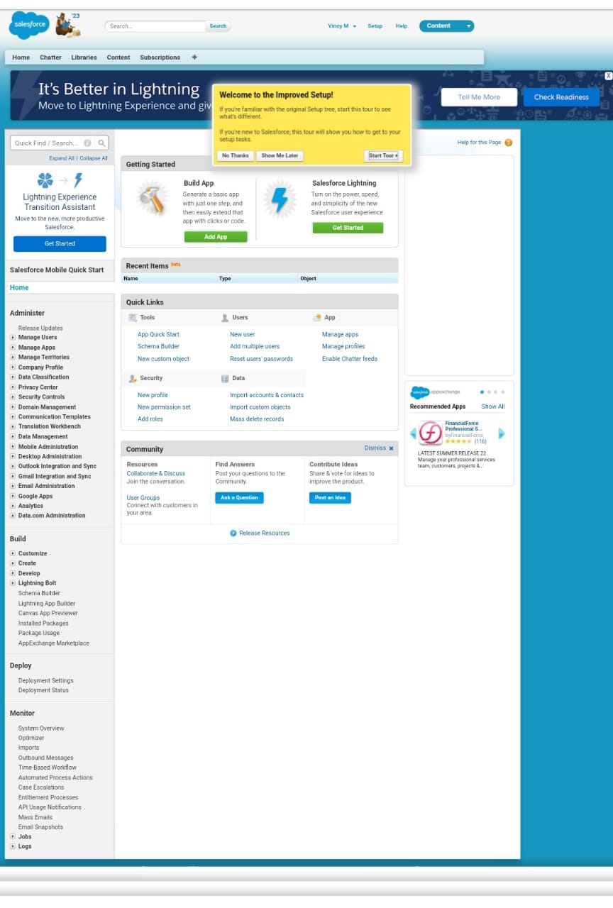3. Result

3.1 Y7

|  |  |
| --- | --- |
| Account Name | name |
| Account number | Text (40) |
| Account Owner | Lookup (user) |
| Account Slite | Text(40) |
| Account Source | Picklist |
| Annual Revenue | Curently (18,0) |
| Billing Address | Address |
| Created By | Lookup(User) |
| Data.Com Key | Text(20) |
| Description | Long Text |
| Employees | Number(8,0) |
| Fax | Fax |
| Industry | Picklist |
| Last Modified By | Lookup |
| Ownership | Picklist |
| Parent Account | Herarchy |

**3.2 Activity & screenshot**

To Creat an Object:

Creation of object for implementing CRM Traacking.

* Go to setup, click manager
* Click creat and select custom object
* Click Save
* Similarly create dashboard.

Similarly create Accountar Object.

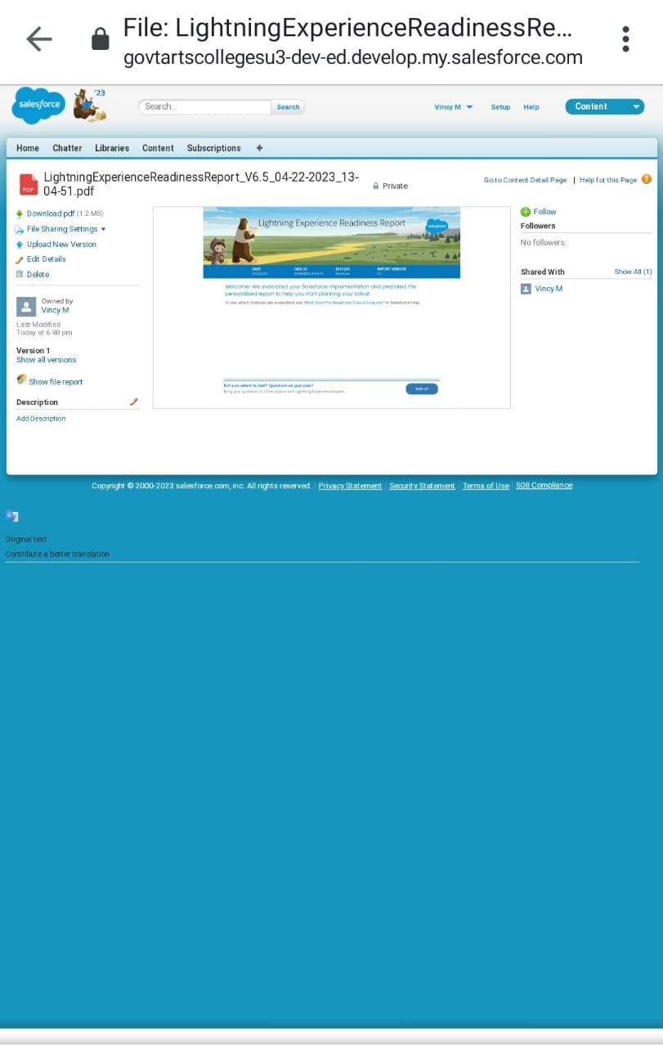

**4.Trailhead Profile Public URL**

Team Lead: https://trailblazer,me/id/vincy1

Team Member 1: https://trailblazer,me/id/boova2

Team Member 2: https://trailblazer,me/id/jeya0

Team Member 3: https://trailblazer,me/id/prema2

**5.Advantages & Disadvantages**

Advantages

* It allows for the consolidation of customer data and the basis for deep insights.
* It speeds up the sales conversion process.
* It increases staff productivity, lowering time cost
* It allows geographically dispeased terms to collaborates effectively
* Improve customer experience by allowing personalization and improved resolution.

Disadvantages

* Customer experience may wersen due to staff over reliance can the system.
* Security and data protection issues with centralized data.
* The excess initial time and productivity cost at the implementing.
* Requires a process driven sales erganization.
* CRM may not suit all business.

**6.Application**

* I want something reliable.
* Target Marketing.
* Increass csndidste quality.
* Can work easily.
* Strcamlining internal scals process.

**7.conclusion**

Student internal marks management system deals with student details, academic related repeat, colleges details and cources details it tracks all the details of a student of a frome the day can to the end of this cource which can be used for all reporting purpose tracking of progress in the cource completed semester upcoming semester details project or any other assignment detail and final exam results.

**8.Future scope**

Scope of education means of view outlook field or opportunity of activity, operation and application og education. Education has a wider meaning and application.